The only candidate who’s not a lawyer, former lobbyist, or career politician legislator
JOB CREATOR – ENTREPRENEUR – COMMON SENSE CONSERVATIVE..
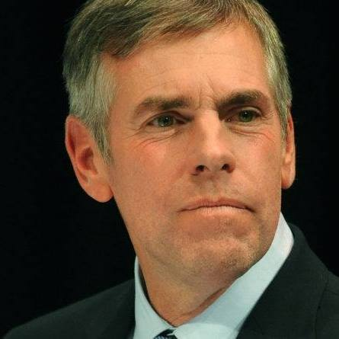
Shawn Moody
Now is not the time to turn Augusta back over to the politicians. Shawn Moody is a proven common sense conservative entrepreneur who started a business at age 17 and grew it to an iconic Maine company with eleven locations. As a leader, after buying and turning around another Maine business he profitably sold, he was chosen by the acquiring company to fix their other locations around the nation by reducing costs and improving efficiencies. He helped that business, in which he has some ownership, grow to an over eight billion dollar company which still employs Maine people. Knowing we must connect the jobs of today with the skills of our students, he was appointed by Governor Paul LePage to serve on both the Community College Board and University Trustees – becoming the first person in Maine history to serve on both at the same time. A massive part of the state budget, he helped reduce costs while holding tuition down. As husband for more than 30 years, he and his wife Chris, a long time Sunday School teacher, have four adult children and two grandchildren. He has been known as an active member of the community assisting charities, co-hosting WGAN news radio’s Saturday Inside Maine show, and speaking to audiences about the struggles he overcame in his youth. As chronicled on Bill Green’s Maine TV show, Shawn’s dramatic life story of growing up as the son of a single mother who struggled with illness, before going on to become a Maine business success, he has been an inspiration to others struggling to get ahead.

STANDING UP FOR FISCAL RESPONSIBILITY: Shawn Moody knows how to cut waste. In his business he is known for his “Tight-N-Up” mantra. As a University Trustee he helped cut over $80 million in operational overhead. Shawn will fight liberal politicians who want to raid the rainy day fund. He’ll build on Governor LePage’s legacy. He will look hold the line.
GROWING JOBS & PROTECTING OUR ECONOMY: As a job creator, Shawn knows red tape and high taxes kill jobs. Shawn will seek to partner with job creators to continue growing Maine’s economy and improve wages. We can’t turn back. Maine must remain Open for Business.
WORK - NOT RUNAWAY WELFARE: We can’t turn the Maine Department of Labor into the Department of Leisure. Shawn struggled in his youth to get ahead and it was hard work which helped him realize the American dream. Work earns people dignity. He will support continued reforms.
SUPPORTING LAW ENFORCEMENT TO FIGHT CRIME AND THE OPIOID CRISIS: The opioid crisis is driving crime. Shawn will help fight this epidemic and support peer-to-peer treatment.
2nd AMENDMENT: Our Constitutional rights must be protected. Shawn will defend our firearm ownership rights and Maine’s outdoor heritage.
OUR VALUES: Despite false attacks, Shawn opposes any taxpayer funded abortions, opposes euthanasia, and supports Maine Right to Life legislative restrictions.
www.ShawnMoody.com
Join our Facebook: www.facebook.com/moodygov
PAID FOR BY SHAWN MOODY FOR GOVERNOR

